**Montgomery County Precinct 3 Constable’s Office**

**Constable Ryan Gable**

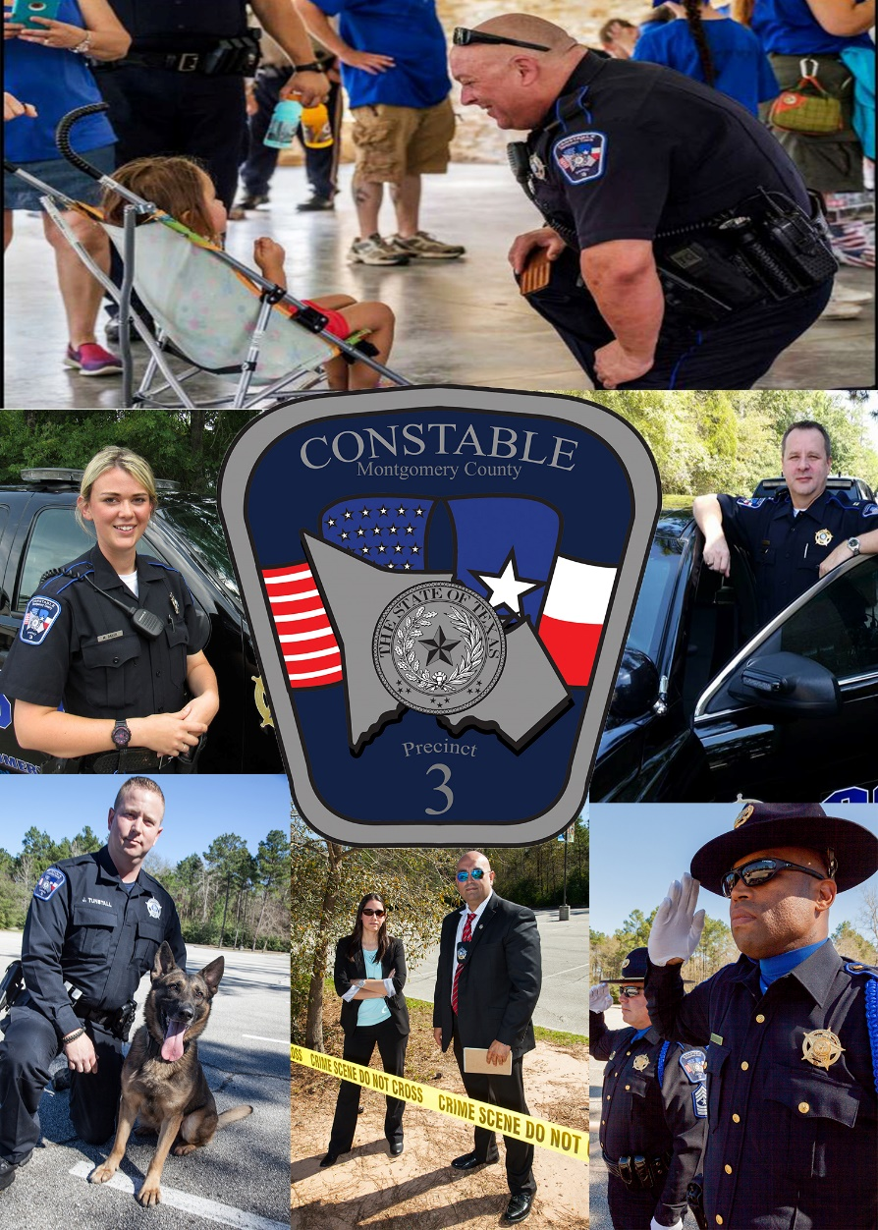

**Strategic Plan 2017-2019**

***Dedicated to protect, proud to serve***

Message from the Constable

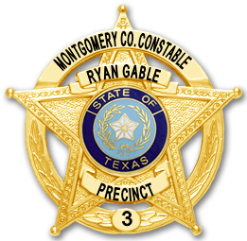I was elected to office in August of 2012 and had a vision to build a professional, proactive and quick to respond law enforcement department. I have a passion to protect our children and created the first unit in Montgomery County to combat child predators using the internet and social media to solicit our children. As we continue to serve the community, I expect our personnel to treat the citizens with compassion and fairness, creating a positive relationship between law enforcement and the people.

We have grown the department by creating positive statistics focusing on traffic contacts, vehicular crashes, narcotics arrests, call response, the serving of civil process and keeping our children safe. We continue to hold ourselves accountable by a customer survey program that provides us feedback from the calls we handle and how the public was treated by the department personnel.

Over the next two years we will continue to develop our leaders, allowing them to better serve our community and inspire those whom they lead. We will enhance existing community partnerships as well as establish new ones. As always we will be implementing goals to help us provide better customer service. By concentrating our efforts and partnering with the community, I know we can make a difference.

I would like to thank the men and women who serve this great agency, sacrificing daily and risking much. Their ranks are made up of sworn and non-sworn, paid employees and volunteers. This agency’s success and future successes of our Vision and Strategic Plan is a credit to their commitment and sacrifice.

I am honored to have the opportunity to serve as your Constable and with your support and God’s will, we can continue to serve the community to your expectations.

Constable Ryan Gable

**Vision Statement**

To be the proactive, quick to respond law enforcement agency of Montgomery County; operating with professionalism, utilizing the spirit of the law when we know we can enforce the color of the law. Continue to grow our agency by displaying to the County and citizens of our precinct, a prestigious level of service, a high production of statistics and exemplary police work. Most importantly create the safest environment for our ever-growing population.

**Mission Statement**

The mission of the Montgomery County Constable’s Office Precinct 3, is to enhance the safety and protect the trust of the citizens of Montgomery County. Our mandate is to do so with honor and integrity, while conducting ourselves with the highest ethical standards to maintain public confidence.

**Values Statement**

In any organization there are values by which we make decisions and through which we hold ourselves accountable. These values are the foundation of all that we do. The Montgomery County Precinct 3 Constable’s Office recognizes five primary values that coincide with the five points of the star we wear:

1. Honesty – We will conduct ourselves in an honest manner in regards to both internal operations and public interactions. We will always endeavor to do what is right.
2. Respect – We show respect in all of our dealings with the community we serve and each other.
3. Honor – We hold the noble call of our office in the highest regard and wear our badge with integrity and pride.
4. Professionalism – We learn and innovate through experience, training and education to ensure we remain on the leading edge of our chosen career.
5. Integrity – We hold ourselves and each other to the highest standards of professional and moral conduct

**Seven Promises of Professional ServicFive**

**Five Promises of Professional Service**

Every day a community member seeks help from an employee of the Montgomery County Precinct 3 Constable’s Office. The reputation of the Constable’s Office is in our hands and we make a lasting impression. In that moment, our voice is louder than all our community involvement programs, advertising and public relations campaigns combined. Our interaction will be remembered. Therefore:

1. As proud members of the Montgomery County Precinct 3 Constable’s Office, we are committed to carrying out our duties to the best of our abilities.
2. We are ambassadors for our Constable and our community, and we realize our appearance is a reflection of our professionalism.
3. We maintain an approachable and helpful demeanor.
4. We are knowledgeable about our duties and our organization, and we work together to achieve our common goals.
5. We make every reasonable effort to answer questions and provide relevant information to those who require assistance.

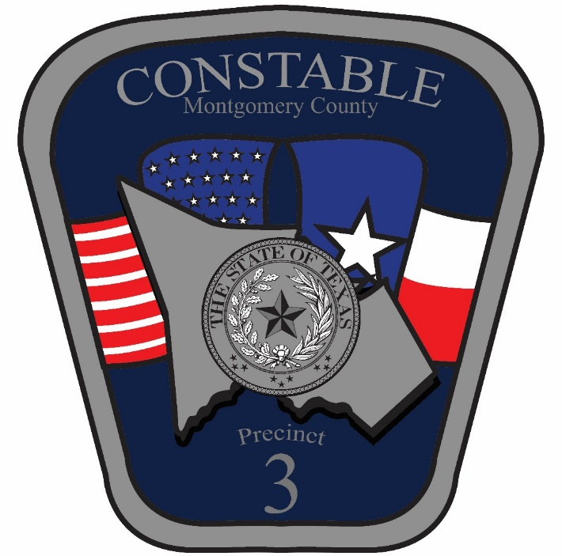

Organizational Structure

Constable

Ryan Gable

Patrol

Civil

Division

Chief Deputy

Matthew Rodrigue

Captain

Dan Zientek

Lieutenant

Jim Sumner

Lieutenant

Mike Atkins

Lieutenant

Scott Furches

Professional Standards

Support

Services

Criminal Investigations Division

Professional

Development

District Patrol

Purchasing/

Inventory

Civil

Process

General Investigations

JP Bailiff

Grants

Contract Patrol

Budget/

Finance

ICAC

Training

Patrol Investigations

Writs

Crimes Against Children

Evidence

K-9 Division

Internal

Affairs

Honor Guard

Inspections/Audits

Fleet Management

Command Team

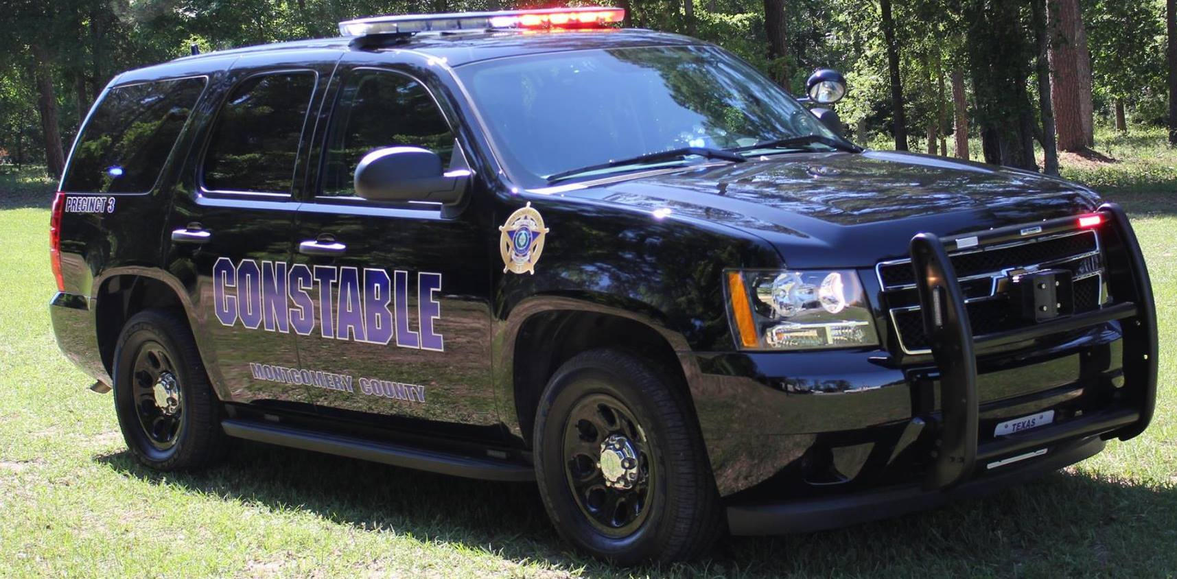

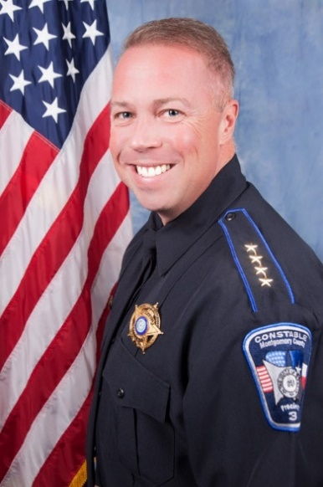**Constable Ryan Gable** started his career with the Harris County Precinct 4 Constable’s Office in 1993. He was initially assigned as an undercover unit posing as a student in an area high school investigating narcotics. He then received an assignment as a Patrol Deputy in the Northwest area of Harris County. He then served time as Detective before being promoted to a Patrol Division supervisor. Constable Gable promoted through the ranks up to the rank of Captain at which time he oversaw the operations of the Civil, Warrants, Training, Domestic Violence and Internet Crimes Against Children Divisions. Constable Gable is a Master Peace officer and a graduate of the Constable’s Command College at Sam Houston State University. He is also a recognized expert in the service of Civil Process and is a noted instructor for the JPCA, Texas Justice Court Training Center and Sam Houston State University. Constable Gable received the 2016 Constable of the Year award for the state of Texas. Constable Gable prides himself on his work with numerous charitable organizations in Montgomery County. Constable is a proud husband and father of two. Constable Gable was elected to his first term in 2012, he ran unopposed for his second term in 2016.

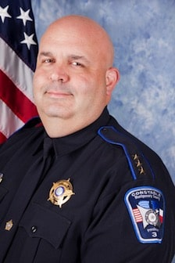**Chief Deputy Matthew Rodrigue** began his career in law enforcement in 1997, and has served with the Harris County Precinct 4 Constable’s Office prior to joining the Montgomery County Precinct 3 Constable’s Office. He is a Master Peace Officer and also holds certifications as an Instructor, Firearms Instructor and a Crime Prevention Specialist. Chief Rodrigue has served as a Patrol Deputy, Field Training Officer, Detective and as a Patrol Sergeant where he oversaw the Canine Unit and Narcotic Interdiction Unit. He served as unit supervisor for both the Warrant and Training Divisions as well. He currently oversees all operations of this office with special emphasis in budgeting, employee relations and he is also the Training Coordinator. Matt serves on the boards of Montgomery Children’s Safe Harbor and the Lone Star College Law Enforcement Academy. Chief Rodrigue is a graduate of the Constable’s Leadership College at Sam Houston State University and is a Trilogy Award Recipient from FBI-LEEDA. He is currently completing the Leadership Command College at Sam Houston State University. He has received 16 exceptional duty commendations. His passion is the outdoors especially hunting. Matt is the proud father of three children.

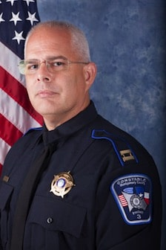**Captain Dan Zientek** Dan Zientek has been a Texas peace officer since 1991 after graduating from University of Houston, starting his law enforcement career in Montgomery County Constable as a reserve before moving to Harris County Constable Precinct 4 in 1992.  Dan promoted through the ranks to Sergeant while in Harris County.  During his time at Harris County he was assigned to patrol, DWI task force, and Investigations of misdemeanor and felony cases not involving serious bodily injury.  While working investigations and fatality accidents he was tasked with crime scene photography.  After serving in this capacity for many years, he would instruct new photographers starting in investigations.  As an FTO he would train new recruits in patrol and investigative procedures.  In 2006 Dan moved to the Montgomery County Sheriff’s Office where he started on patrol and quickly moved to the Criminal Investigation Division.   In 2008 Dan became an adjunct instructor for TEEX Forensic Science Academy, a division of Texas A&M University.   Dan currently teaches Criminal Investigations, Death Investigations and Forensic Photography.   Dan is a member of the International Association of Identification, International Homicide Investigators Association, Association of Crime Scene Reconstruction, and International Law Enforcement Educators and Trainers.  Dan is licensed through TCOLE as a Master Peace Officer, Special Investigator and Instructor.  Dan Holds Certifications Through TEEX Forensic Science Academy for Forensic Investigator I and II, Major Crimes Investigator, and Property and Evidence Management.  During his time in Major Crimes Dan was promoted to Senior Sergeant over the unit and in 2014 to Lieutenant over Major Crimes, Persons Crimes, Crimes against Children and Sex Offender compliance unit. In 2016 Dan promoted to an administrative Captain with Montgomery County Precinct 3 Constable Office.

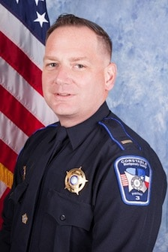**Lieutenant Michael Atkins** Lieutenant Atkins is a native of Houston, TX. He attended Alief Elsik High School and currently attends Sam Houston State University majoring in Criminal Justice. Mike came to Montgomery County Precinct 3 after serving in the United States Marine Corps and the Harris County Precinct 4 Constables Office. During his time in the Marine Corps, he deployed twice in support of Operation Iraqi Freedom. During the Iraqi invasion, Lt. Atkins served as the Personal Security Detail Section Leader for Lt. General James Conway. On his second deployment to Al Ramadi, Iraq, Lt. Atkins served as Force Protection NCO while stationed at the Al Anbar Government Center. During each deployment, Mike earned a Marine Corps Achievement Medal for outstanding performance. While at Harris County Precinct 4, he investigated numerous fatality accidents, worked on a full time Narcotic Interdiction Unit and cleared numerous high profile cases. In 2011 and 2012, Lt. Atkins was awarded the Outstanding Achievement Award for his work on two large crimes that were taxing to Law Enforcement. During his time in Law Enforcement, Mike has worked in Patrol, Narcotic Interdiction, Accident Investigation, Investigations and Recruiting. Leadership training includes the FBI LEEDA Trilogy series, Texas Police Chiefs Association Developing Leaders Series and the LEMIT Leadership Command College. He is a Master Peace Officer and is currently supervising the Criminal Investigation, Civil and Training Divisions. Mike is an avid outdoorsman and shooting enthusiast.

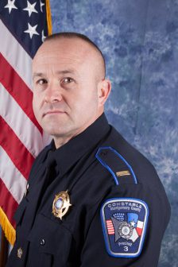Lieutenant Scott Furches has been a Texas Peace Officer since 1990 after graduating from The University of Houston – Downtown. He began his career with Harris County Constable Precinct 4 as a Patrol Deputy and worked several assignments in the precinct. In 1996, he joined the accident investigation unit and assisted with major/ fatality accident investigations. Scott then transitioned into the Reserve Division to pursue opportunities in the private business world, where he grew his business into the largest multi – franchise development within the company. Lieutenant Furches continued serving the reserve division and rose to the rank of Captain. In 2012 Scott joined Montgomery County Constable Precinct 3. Lieutenant brings a sustained history of executive level leadership experience to the agency. He is a Master Peace Officer, Instructor, Field Training Officer – Administrator, and a Trilogy Award Recipient from FBI-LEEDA.

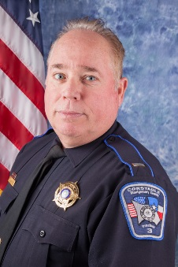**Lieutenant Jim Sumner** graduated the Harris County Sheriff’s Office Academy in March of 1980 Lieutenant Jim Sumner began his Law enforcement career with the Precinct 4 Constable’s Office. As a deputy, he obtained the necessary training to become an Accident Re-constructionist, Crime Scene Investigator and Photographer and Instructor. He served in this capacity for several years attending specialized training the Texas A & M University. In 1990, Jim completed the writing and implementation of the Department Policy and Ethics Manuel and Patrol Division S. O. P. After being promoted to Sergeant, he enjoyed teaching new recruits patrol tactics. He still enjoys teaching new law enforcement administrators at Sam Houston State University. Lieutenant Sumner continued to promote through the ranks working closely with department staff and in 2001 was appointed Chief Deputy where he served for 15 years. In May 2015 Jim was appointed Assistant Chief of the Law Enforcement Command at the Harris County Sheriff’s Office over five commands and 2000 personnel until his retirement December 2016. Interested in the supervision and management of law enforcement, Lieutenant Sumner attended the Constable’s Leadership Institute, the Bill Blackwood Law Enforcement Management Institute at Sam Houston State University, FBI Law Enforcement Development, Command College and the F.B.I. National Academy Graduate Class 247. January 9, 2017, Lieutenant Sumner became a member of the Montgomery County Precinct 3 Constable’s Office. Jim is married to Becky, they have three children, seven grandchildren. He and his family enjoy hunting, fishing, travelling, golf and outdoor grilling by the pool.

Constable’s Office

At A Glance

The Montgomery County Precinct 3 Constable’s Office serves a 200 square mile jurisdiction within southern Montgomery County. This area includes the cities of Shenandoah and Oak Ridge North. In 2015 the population was approximately 210,000 residents with more growth coming every day.

Our agency currently employs 47 people, 44 are sworn fulltime peace officers and we have a civilian clerical staff of 3. We also have a reserve division comprised of 13 fully empowered deputies. As well as a volunteer based Victim Services Unit.

Our office is located at 1520 Lake Front Circle, Suite 200, The Woodlands, TX 77380. In 2016 our office ran 58,000 calls for service, investigated 468 vehicle crashes, made 12,768 traffic contacts, served 2,653 pieces of civil process and filed 858 charges.

Every year our employees attend thousands of hours of training keeping them up to date on methods and standards in policing. Annual training includes CPR, First Aide, TASER and ASP training among others. Our office has also established a partnership with FBI-LEEDA to bring nationally recognized leadership training to Montgomery County for our supervisors.

This office was received recognized status from the Texas Police Chiefs Association as meeting the highest standards of professionalism in law enforcement, we were the first county agency of any kind in the state to achieve this status.

We have also pioneered other programs such as weekly customer service surveys for the citizens whom call us for assistance and we are currently working with Sam Houston State University to develop and employee satisfaction survey and enhancement program.



**Vision Statement**

To be the proactive, quick to respond law enforcement agency of Montgomery County; operating with professionalism, utilizing the spirit of the law when we know we can enforce the color of the law. Continue to grow our agency by displaying to the County and citizens of our precinct, a prestigious level of service, a high production of statistics and exemplary police work. Most importantly create the safest environment for our ever-growing population.

**Mission Statement**

The mission of the Montgomery County Constable’s Office Precinct 3, is to enhance the safety and protect the trust of the citizens of Montgomery County. Our mandate is to do so with honor and integrity, while conducting ourselves with the highest ethical standards to maintain public confidence.

**Values Statement**

In any organization there are values by which we make decisions and through which we hold ourselves accountable. These values are the foundation of all that we do. The Montgomery County Precinct 3 Constable’s Office recognizes five primary values that coincide with the five points of the star we wear:

1. Integrity – We hold ourselves and each other to the highest standards of professional and moral conduct.
2. Honesty – Choosing to conduct ourselves with honestly and thoughtfulness in all dealings.
3. Professionalism – We hold ourselves to strive to achieve and maintain the highest level of professional standards through training and constant oversight.
4. Honor – We hold the noble call of our office in the highest regard and wear our badge with integrity and pride.
5. Respect – We commit to respect not only the community we serve but our fellow co-workers and ourselves.

Planning Process

Strategic planning is an organizational process of envisioning a desired future and translating that vision into broadly defined goals and a sequence of strategies to achieve them. Our duty at the Montgomery County Precinct 3 Constable’s Office is to serve, protect and defend our community by implementing strategies and partnerships that will prevent and reduce crime in order to enhance our community’s quality of life.

In order to meet our objective, Constable Gable and the Command Team have prioritized three goals that remain constant year to year and guide our objectives. The first goal is aimed internally at our most valuable resource, and the key to our agency’s success, our personnel. The second and third goals are aimed externally; one focused on reduction of crime and one focused on customer service.

Under these three goals, objectives are developed. The Constable and his Command Team look at crime trends and the problems, deficiencies and needs facing our agency and community to develop specific, measurable and achievable objectives. Once in place, these objectives will be released to the agency where division leadership generates specific strategies for each division. This form of inclusive strategy development creates a shared responsibility throughout the agency.

When Constable Gable took office, the agency did not have a comprehensive strategic plan in place, definitely not one that united the entire agency and affected the day-to-day operations in the achievement of our vision. Constable Gable has a desire to improve morale and develop a plan that would change the culture and focus of the Constable’s Office.

With our full agency working towards these objectives we look to achieve substantial success. As we have progressed in strategic planning we are developing yearly objectives through the 2018 calendar year. Starting in 2017, we will adopting a two year strategic plan. As you will see, each of our 2017-2019 objectives build upon those ideals that came before and further our progress in the achievement of our shared vision.

Implementation

& Evaluation

Strategic plans are only as effective as the methods employed to make the plan a reality. The following pages are an implementation plan that will serve as a blueprint for employees to make our goals and objectives a reality. Included in this plan are specific objectives with the strategies we will utilize to achieve them, along with the responsible division(s) and/or person(s), and projected completion dates.

A great feature of this plan is found in its adaptability and flexibility. If a strategy is found to be ineffective, it can easily be changed. As new crime data and challenges arise, we will regularly evaluate our strategies to ensure their effectiveness. Divisions, and of course the Command Team, will meet regularly to gauge our progress.

By outlining and assigning strategies to specific divisions/people and linking them to projected completion dates we have orchestrated a system that encourages accountability and ownership. In most cases our results will be traceable and quantifiable. Crime data and community feedback will provide valuable information that will allow us to adjust our strategies and plan for the future. Some effects of our strategic plan will reveal themselves in less calculable ways. Effects such as higher moral and greater agency pride are just the beginning of the less measurable benefits this Strategic Plan will impart.

Goals, Objectives and Strategies

**Goal 1: We will use our financial and human resources fairly, efficiently and effectively**

**Objective 1.1:** Expansion and maintenance of Agency-wide Leadership Continuum

|  |  |
| --- | --- |
| **Strategy: 1.1a – Mandatory training for all first line and command supervisors through the FBI-LEEDA program.** | **Division/Person(s) Responsible:**  Chief Deputy Rodrigue/ Lt. Sumner |
| **Description:** Our first line supervisors are the heart of our chain of command. They are the communication link between the employees and administration and they have great responsibility concerning employee productivity, morale and development. We want to better equip our supervisors by implementing training through FBI-LEEDA based on the challenges they face. | **Status:** *In process*  **Projected Completion Date:** Ongoing |

|  |  |
| --- | --- |
| **Strategy: 1.1b – Ensure continuing executive level training for Sergeants & above.** | **Division/Person(s) Responsible:**  Chief Deputy Rodrigue |
| **Description:** Mandate that all supervisors upon achieving the rank of Sergeant apply to at the Leadership Command College at LEMIT within the first 6 months of promotion. | **Status:** *In process*  **Projected Completion Date:**  Ongoing |

|  |  |
| --- | --- |
| **Strategy: 1.1c – Tactical Active Shooter Training for all sworn employees.** | **Division/Person(s) Responsible:**  Lieutenant Atkins |
| **Description:** We will be providing training in Active Shooter training for all sworn agency personnel to include ALERRT levels I and II. | **Status:** *In process*  **Projected Completion Date:**  December 31, 2018 |

**Objective 1.2:** Physical Fitness Incentive Program

|  |  |
| --- | --- |
| **Strategy: 1.2 – Physical Fitness Incentive Program** | **Division/Person(s) Responsible:**  Captain Zientek/ Lieutenant Sumner |
| **Description:** Creation and review for implementation of Physical Fitness Incentive Program begins by December 31st, 2017. Should Constable approve program, implementation by December 31st, 2018. | **Status:** *In process*  **Projected Completion Date:**  Creation and Review-  December 31, 2017  Implementation if approved-  December 31, 2018 |

**Objective 1.3:** Agency Wide Employee Satisfaction Survey

|  |  |
| --- | --- |
| **Strategy: 1.3 – Agency Wide Employee Satisfaction Survey** | **Division/Person(s) Responsible:**  Chief Deputy Matt Rodrigue |
| **Description:** Creation and review for implementation of Employee Satisfaction Survey. We will team up with Sam Houston State University to issue employee satisfaction survey to all employees and then analyze the data and address areas of improvement. | **Status:** *In process*  **Projected Completion Date:**  July 1, 2017 |

**Goal 2: We will reduce targeted crime in Montgomery County Precinct 3**

**Objective 2.1:** Reduce Domestic Violence involved incidents within Montgomery County Precinct 3.

|  |  |
| --- | --- |
| **Strategy: 2.1a – Community Education on Domestic Violence Victims Rights** | **Division/Person(s) Responsible:**  Captain Zientek |
| **Description:** We will utilize a community approach that brings all stakeholders to the table working. We will work with area shelters and the Montgomery County District Attorney’s Office to educate the community in regards to domestic violence victim’s rights. | **Status:** *In process*  **Projected Completion Date:**  12/31/2017 |

|  |  |
| --- | --- |
| **Strategy: 2.1b – Training of Patrol in DV response** | **Division/Person(s) Responsible:**  Lieutenant Sumner |
| **Description:** All of our patrol employees will receive (initial and on-going) training in domestic violence response and the cycle of violence. | **Status:** *In process*  **Projected Completion Date:**  Ongoing |

**Objective 2.2:** Increase DWI enforcement within Montgomery County Precinct 3.

|  |  |
| --- | --- |
| **Strategy: 2.2a – Provide certification/ recertification of DWI standardized field sobriety tests for all patrol personnel.** | **Division/Person(s) Responsible:**  Lieutenant Sumner |
| **Description:** All agency patrol personnel with attend SFST certification/recertification to aide in the enforcement of driving while intoxicate offenses. | **Status:** *In process*  **Projected Completion Date:**  09/01/2017 and ongoing |

|  |  |
| --- | --- |
| **Strategy: 2.2b – Participate in area DWI enforcement efforts.** | **Division/Person(s) Responsible:**  Lieutenant Furches |
| **Description:** We will participate in No Refusal Weekend events within Montgomery County. | **Status:** *In process*  **Projected Completion Date:**  Ongoing |

|  |  |
| --- | --- |
| **Strategy: 2.2c – Establish agency specific DWI enforcement events throughout the year.** | **Division/Person(s) Responsible:**  Lieutenant Furches |
| **Description:** We will assign multiple units during designated times throughout the year to specifically target impaired driving offenses. | **Status:** *In process*  **Projected Completion Date:**  Ongoing |

**Objective 2.3:** Increase the forensic tools needed to keep up with changing technology in Internet Crimes Against Children by December 31st, 2018

|  |  |
| --- | --- |
| **Strategy: 2.3a – Purchase Forensic computer, Cellebrite, forensic software** | **Division/Person(s) Responsible:**  Lieutenant Atkins |
| **Description:** We will purchase software and hardware for the purpose of tracking the online sharing of child pornography and use of electronics in Crimes against children. Hardware and software will be used for forensic examination of cell phones, computers, GPS and other electronic devices used in criminal activities. | **Status:** *In process*  **Projected Completion Date:**  Ongoing |

**Objective 2.4:** Increase proactive measures in cases of Crimes against children by 20%

|  |  |
| --- | --- |
| **Strategy: 2.4a – Increase the amount of undercover chat operations leading to more cases.** | **Division/Person(s) Responsible:**  Lieutenant Atkins |
| **Description:** Utilizing latest technologies we will set up undercover chat operations for the purpose of having suspects contact undercover officers believing they are communicating with children to meet for sex. | **Status:** *In process*  **Projected Completion Date:**  20% increase every 6 months |

**Objective 2.5:** Provide training and build relationships to better investigate Sexual assaults, family violence, and juvenile runaways/human trafficking

|  |  |
| --- | --- |
| **Strategy: 2.5a – Send patrol and investigators to SAFVIC and Family violence strangulation course** | **Division/Person(s) Responsible:**  Lieutenant Atkins/Lieutenant Furches |
| **Description:** We will send patrol and investigators to TCOLE Sexual Assault Family Violence Investigators Course (SAFVIC) and also attend the family violence strangulation course from Montgomery County D.A.’s office. | **Status:** *In process*  **Projected Completion Date:**  Ongoing |

|  |  |
| --- | --- |
| **Strategy: 2.5b – Build relationships with woman’s shelters and counseling services in the community** | **Division/Person(s) Responsible:**  Lieutenant Furches/Lieutenant Atkins |
| **Description:** we will build contacts and relationships with employees of the shelters to build trust needed in difficult cases for outcry such as human trafficking and continued abuse | **Status:** *In process*  **Projected Completion Date:**  Ongoing |

**Objective 2.6:** Network with surrounding area agencies to share information on investigations

|  |  |
| --- | --- |
| **Strategy: 2.6a – Attend Monthly Investigation meetings with Conroe Police Department** | **Division/Person(s) Responsible:**  Lieutenant Atkins/Lieutenant Furches |
| **Description:** We will attend the monthly investigation meeting hosted by Conroe Police Department consisting of surrounding agencies. | **Status:** *In process*  **Projected Completion Date:**  Ongoing |

|  |  |
| --- | --- |
| **Strategy: 2.6b –** **Attend Montgomery County Human Trafficking prevention meetings** | **Division/Person(s) Responsible:**  Lieutenant Atkins |
| **Description:** We will attend the meetings to obtain training and insight into current trends and investigations in our area. | **Status:** *In process*  **Projected Completion Date:**  Ongoing |

|  |  |
| --- | --- |
| **Strategy: 2.6c – Attend Montgomery County Child Fatality Review Team** | **Division/Person(s) Responsible:**  Lieutenant Atkins |
| **Description:** We will attend to share information on cases and be part of public awareness projects in Montgomery County. | **Status:** *In process*  **Projected Completion Date:**  Ongoing |

**Goal 3: We will provide high quality service to the citizens of Montgomery County Precinct 3.**

**Objective 3.1:** Establish and implement a Citizens Police Academy

|  |  |
| --- | --- |
| **Strategy: 3.2a – Establish and implement a Citizens Police Academy** | **Division/Person(s) Responsible:**  Lt. Atkins/ Lt. Sumner |
| **Description:** Design and establish and Citizens Police Academy for the citizens of our precinct. Design a working program and curriculum. | **Status:** *In process*  **Projected Completion Date:**  12/31/2017 |

**Objective 3.2:** Enhance weekly communications to our community on the activities of this office.

|  |  |
| --- | --- |
| **Strategy: 3.3a – Implement a weekly crime blotter.** | **Division/Person(s) Responsible:**  Captain Zientek |
| **Description:** Create and distribute weekly crime blotters to our local media outlets and agency social media sources. | **Status:** *In process*  **Projected Completion Date:**  Ongoing |

**Objective 3.3:** Increase random deputy patrols to our schools

|  |  |
| --- | --- |
| **Strategy: 3.4 - Deputy Patrols of Schools** | **Division/Person(s) Responsible:** Lt. Furches |
| **Description:** In addition to the law enforcement presence created by our area ISD Police Department, we pledge to increase random deputy patrols to our schools. | **Status:** *In process*  **Projected Completion Date:**  Ongoing |

**Objective 3.4:** Provide Community Education and Outreach Programs

|  |  |
| --- | --- |
| **Strategy: 3.4a – Increase annual citizen educational outreach events and programs.** | **Division/Person(s) Responsible:**  Lieutenant Atkins/ Lieutenant Sumner/Lieutenant Furches |
| **Description:** Programming will include:   * Children’s outreach ICAC investigators involving education in online safety and cyberbullying. * Parent’s outreach ICAC investigators involving education in online safety and cyberbullying. * Gun Safety Education and gun lock giveaway * Residential Security Education * ID Protection | **Status:** *In process*  **Projected Completion Date:**  07/01/2017  **Implementation Date:**  Ongoing |

|  |  |
| --- | --- |
| **Strategy: 3.4b – Community Interaction Events** | **Division/Person(s) Responsible:**  Chief Rodrigue/ Lt. Furches |
| **Description:** Facilitate and participate in scheduled community interactions events:   * Coffee with the Cops * National Night Out * Law Enforcement Outreach in our Contracts * Prescription Turn in Events | **Status:** *In process*  **Projected Completion Date:**  Ongoing |

Moving Forward

We would like to recognize the hard work and dedication of the members of the Montgomery County Precinct 3 Constable’s Office who brought this plan to fruition. Thank you for your valuable contributions and participation in this Strategic Plan and those to come.

